**CHAPTER ONE**

**INTRODUCTION**

* 1. **Background of Study**

A smart RFID Student ID card reader is an IoT device that attempts to close the gap between our school’s online servers and the people. It offers a unique way to get information about a particular student without specifically needing a computer or phone; through their ID cards. The device makes use of Radio Frequency Identification Technology, which means the student only needs to bring their ID cards within a 5cm reach of the device to be scanned. RFID tech eliminates the problems of visibility and scratches that make reading difficult. The device also comes with a website where all info/stats can be downloaded by staff in digitized format (Excel and CSV). This technology is important because it eliminates the need for recording info on paper. Data can be retrieved or stored from the server with the device acting as a bridge and the website acting as its face.

In a world of growing complexity, new methods and strategies have to be developed to make the life of everyone easier, faster and more efficient. Technological advancements play a large part in making this possible. In the past all paper work had to be written by hand, signed and transported by train before it could get to its destination; today that is no longer the case. Phones and the internet have totally changed the way we transmit information.

The internet of things, or IoT, is a network of physical objects: “things” that are embedded with sensors, software, and other technologies for the purpose of connecting and exchanging data with other devices and systems over the internet. These devices range from ordinary household objects like temperature sensors to sophisticated industrial tools like military radar (Gillis, 2022). By means of low-cost computing, the cloud, data analytics, and mobile technologies, physical things can share and collect data with minimal human intervention. In this hyper connected world, digital systems can record, monitor, and adjust each interaction between connected things. The physical world meets the digital world and they cooperate.

Radio-frequency identification (RFID) IoT devices and sensors use electromagnetic fields to automatically identify and track tags attached to objects. (“Radio Frequency Identification”, 2022) Meaning they don’t need physical touch to be detected. They only need to be close enough.

A microcontroller is a compact integrated circuit designed to govern a specific operation in an embedded system. A typical microcontroller includes a processor, memory and input/output (I/O) peripherals on a single chip.

Sometimes referred to as an embedded controller or microcontroller unit (MCU), microcontrollers are found in vehicles, robots, office machines, medical devices, mobile radio transceivers, vending machines and home appliances, among other devices. They are essentially simple miniature personal computers (PCs) designed to control small features of a larger component, without a complex front-end operating system (OS).

* 1. **Problem Statement**

Current administrative tasks and activities in Nigerian schools and corporate offices can be made faster and much more efficient. Manual administrative tasks in developed countries are almost nonexistent. It should be the same here in Nigeria, but we have an issue of slowed technological advancement.

According to Princewill Ene (Ene, 2022) There are many factors that affect development of science and technological advancement in Nigeria, including but not limited to:

* Lack of funds
* Lack of expertise
* Low level of education
* Lack of appropriate market
* Inadequate infrastructure
* Poverty
* Economic fluctuation
* Political instability
* Ethnicity
* Social vices

With these problems in mind, for technology to be feasible in Nigeria, it has to be: cheap, easy to operate, secure, durable, solve an important problem, small, consume low power and be cheap to maintain. As impossible as all this sounds, with the right tools, technology and mindset it can be done. A simple device that scans student’s ID cards, confirms their info from an online database, and returns a simple yes or no response. This will help boost administrative efficiency and reduce paperwork.

* 1. **Aim and Objectives**

The aim of this project is to design and implement a smart RFID student ID Card Reader. The following objectives will be achieved;

* Design and build a small hardware device that connects to the internet through Wi-Fi.
* Design and build a small hardware device that can read RFID tags.
* Design and build a small hardware device that runs on minimal electricity and uses batteries.
* Design and build a small hardware device that is easy to use and understand.
* Design and build a website hosted online that communicates efficiently with the small hardware device.
* Design and build a website hosted online that stores the data gotten from the small hardware device.
* Design and build a website hosted online that lets its users download summarized data in any of these formats: Excel and CSV.
* Build a fully functional Iot device that can scan student’s RFID enabled ID cards and confirm/store any data needed.
  1. **Significance of the Study**
* Make administrative tasks like checking for fee payment, leasing library books, taking attendance faster and more efficient
* Make the life of students and staff easier
* Reduce the use of hardcopy
* Boost data analysis through direct electronic data availability
* Higher security through advanced monitoring of students from their entries and direct confirmation from an online database
* Reduce our carbon footprints through burning of paper containing information that is readily available online
  1. **Scope of the Study**

The scope of this study covers the hardware device and online website that holds all the needed data and functionality. It also covers the students and staff of ESUT.

* 1. **Limitation of the Study**
* Purchase of the RFID enabled cards and assigning them to each student
* Cannot work without an internet active Wi-Fi hotspot device
* Each Wi-Fi hotspot device has to be set to a particular Wi-Fi name and password for the device to find.
  1. **Organization of the Report**

This project report is organized into five chapters:

**Chapter One:** The whole idea behind the work. Includes objective of the study, statement of the research, area of coverage limitation and definition of terms.

**Chapter Two:** This section deals with the review of study, review of concept theories upon which this work is built on and the potential issues

**Chapter Three:** This section talks about the software and hardware tools used in the project. The methodology at which this research work will be implemented.

**Chapter Four:** The system is implemented and presented with its analysis. Functions are in depth explained for reader understating and comprehension. The system requirements are also detailed.

**Chapter Five:** Summarizes the whole work done and makes possible recommendation and suggest other points to be included into the work for future propose

* 1. **Definition of Terms**

1. IoT: The internet of things, or IoT, is a system of interrelated computing devices, mechanical and digital machines, objects, animals or people that are provided with unique identifiers (UIDs) and the ability to transfer data over a network without requiring human-to-human or human-to-computer interaction (Gillis, 2022).
2. Sensors: A sensor is a device that produces an output signal for the purpose of sensing a physical phenomenon.
3. RFID: Radio-frequency identification (RFID) uses electromagnetic fields to automatically identify and track tags attached to objects (Radio Frequency Identification, 2022).
4. RFID Tags: A radio-frequency identification system uses tags, or labels attached to the objects to be identified. Two-way radio transmitter-receivers called interrogators or readers send a signal to the tag and read its response (“Radio Frequency Identification”, 2022).
5. Microcontroller: A microcontroller contains one or more CPUs (processor cores) along with memory and programmable input/output peripherals. Microcontrollers are designed for embedded applications, in contrast to the microprocessors used in personal computers or other general-purpose applications consisting of various discrete chips (“Microcontroller”, 2022).
6. Input/Output(I/O): In computing, input/output (I/O, i/o, or informally io or IO) is the communication between an information processing system, such as a computer, and the outside world, possibly a human or another information processing system. Inputs are the signals or data received by the system and outputs are the signals or data sent from it (“General Purpose Input/Output”, 2022).
7. Wi-Fi: A family of wireless network protocols, based on the IEEE 802.11 family of standards, which are commonly used for local area networking of devices and Internet access, allowing nearby digital devices to exchange data by radio waves. These are the most widely used computer networks in the world, used globally in home and small office networks to link desktop and laptop computers, tablet computers, smartphones, smart TVs, printers, and smart speakers together and to a wireless router to connect them to the Internet, and in wireless access points in public places like coffee shops, hotels, libraries and airports to provide visitors with Internet connectivity for their mobile devices (“Wi-Fi”, 2022).
8. Wi-Fi Hotspot: A hotspot is a physical location where people can obtain Internet access, typically using Wi-Fi technology, via a wireless local-area network (WLAN) using a router connected to an Internet service provider (“Wi-Fi”, 2022).
9. Website: is a collection of web pages and related content that is identified by a common domain name (google.com, yahoo.com etc.) and published on at least one web server.
10. Online Hosting/Cloud Hosting: is the on-demand availability of computer system resources, especially data storage (cloud storage) and computing power, without direct active management by the user.
11. NodeMCU: is an open source firmware for which open source prototyping board designs are available (“NodeMCU”, 2022).
12. MRC522 RFID Sensor: The RC522 RFID Reader/Writer Module (Transceiver) is based on a highly integrated reader/writer IC MFRC522 from NXP Company. It is used for contactless Multi-communication at 13.56 MHz (“Radio Frequency Identification”, 2022).
13. Arduino IDE: The Arduino Integrated Development Environment - or Arduino Software (IDE) - contains a text editor for writing code, a message area, a text console, a toolbar with buttons for common functions and a series of menus. It connects to the Arduino hardware to upload programs and communicate with them (“Arduino”, 2022).
14. VS Code: Visual Studio Code, also commonly referred to as VS Code, is a source-code editor made by Microsoft with the Electron Framework, for Windows, Linux and macOS. Features include support for debugging, syntax highlighting, intelligent code completion, snippets, code refactoring, and embedded Git (“Visual Studio Code”, 2022).
15. PHP: is a general-purpose scripting language geared toward web development (“PHP”, 2022).
16. JavaScript: JS, is a programming language that is one of the core technologies of the World Wide Web, alongside HTML and CSS (“JavaScript”, 2022).
17. MySQL: is an open-source relational database management system (RDBMS). Its name is a combination of "My", the name of co-founder Michael Widenius's daughter My, and "SQL", the acronym for Structured Query Language (“SQL”, 2022).
18. Git: is a distributed version control system: tracking changes in any set of files, usually used for coordinating work among programmers collaboratively developing source code during software development.
19. GitHub: GitHub, Inc is an Internet hosting service for software development and version control using Git. It provides the distributed version control of Git plus access control, bug tracking, software feature requests, task management, continuous integration, and wikis for every project.
20. Debug: In computer programming and software development, debugging is the process of finding and resolving bugs (defects or problems that prevent correct operation) within computer programs, software, or systems.
21. LEDs: A light-emitting diode (LED) is a semiconductor device that emits light when current flows through it. Electrons in the semiconductor recombines with electron holes, releasing energy in the form of photons.
22. Buzzers: A buzzer or beeper is an audio signaling device, which may be mechanical, electromechanical, or piezoelectric (piezo for short). Typical uses of buzzers and beepers include alarm devices, timers, train and confirmation of user input such as a mouse click or keystroke.

**CHAPTER TWO**

**LITERATURE REVIEW**

1. **Overview of Relevant Technology**

Radio-frequency identification (RFID) uses electromagnetic fields to automatically identify and track tags attached to objects. An RFID system consists of a tiny radio transponder, a radio receiver and transmitter. When triggered by an electromagnetic interrogation pulse from a nearby RFID reader device, the tag transmits digital data, usually an identifying inventory number, back to the reader. This number can be used to track inventory goods (“Radio Frequency Identification”, 2022).

Passive tags are powered by energy from the RFID reader's interrogating radio waves. Active tags are powered by a battery and thus can be read at a greater range from the RFID reader, up to hundreds of meters.

Unlike a barcode, the tag does not need to be within the line of sight of the reader, so it may be embedded in the tracked object. RFID is one method of automatic identification and data capture.

RFID tags are used in many industries. For example, an RFID tag attached to an automobile during production can be used to track its progress through the assembly line, RFID-tagged pharmaceuticals can be tracked through warehouses, and implanting RFID microchips in livestock and pets enables positive identification of animals. Tags can also be used in shops to expedite checkout, and to prevent theft by customers and employees.

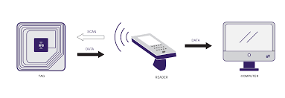

**Fig 2.1: RFID Technology**

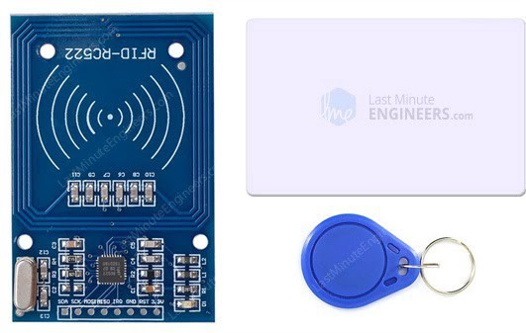

**Fig 2.2: RC522 RFID Module with Its two Tags**

Since RFID tags can be attached to physical money, clothing, and possessions, or implanted in animals and people, the possibility of reading personally-linked information without consent has raised serious privacy concerns. These concerns resulted in standard specifications development addressing privacy and security issues.

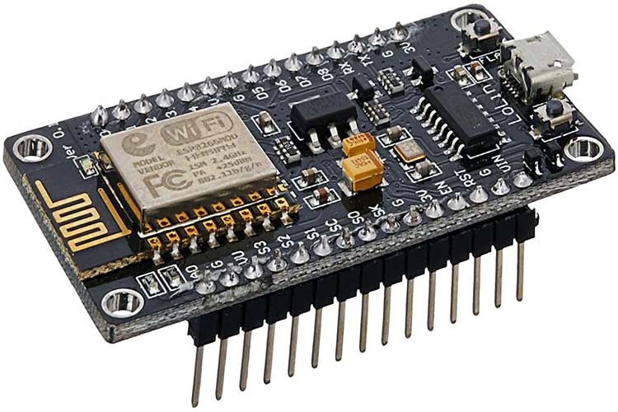

**Fig 2.3: NodeMCU ESP8266 Microcontroller with USB Connector**

The NodeMCU is a low-cost open source IoT platform. Its initial versions included firmware which runs on the ESP8266 Wi-Fi SoC from Espressif Systems. The firmware uses the Lua scripting language and is based on the eLua project, and built on the Espressif Non-OS SDK for ESP8266. It uses many open source projects, such as lua-cjson and SPIFFS (“NodeMCU”, 2022).

ESP8266 is a highly integrated chip designed for the needs of a new connected world. It offers a complete and self-contained Wi-Fi networking solution, allowing it to either host the application or to offload all Wi-Fi networking functions from another application processor. This module comes with a built in USB connector and a rich assortment of pin-outs. With a micro USB cable, you can connect the NodeMCU devkit to your laptop and flash it without any trouble, just like Arduino. It is also immediately breadboard friendly.

NodeMCU was created shortly after the ESP8266 came out. On December 30, 2013, Espressif Systems began production of the ESP8266. NodeMCU started on 13 Oct 2014, when Hong committed the first file of nodemcu-firmware to GitHub. Two months later, the project expanded to include an open-hardware platform when developer Huang R committed the gerber file of an ESP8266 board, named devkit v0.9.

In the summer of 2015, the original creators abandoned the firmware project and a group of independent contributors took over. By the summer of 2016 the NodeMCU included more than 40 different modules.

**NodeMCU ESP8266 Specifications & Features**

* Microcontroller: Tensilica 32-bit RISC CPU Xtensa LX106
* Operating Voltage: 3.3V
* Input Voltage: 7-12V
* Digital I/O Pins (DIO): 16
* Analog Input Pins (ADC): 1
* UARTs: 1
* SPIs: 1
* I2Cs: 1
* Flash Memory: 4 MB
* SRAM: 64 KB
* Clock Speed: 80 MHz
* USB-TTL based on CP2102 is included onboard, Enabling Plug n Play
* PCB Antenna
* Small Sized module to fit smartly inside your IoT projects

1. **Review of Related Work**

For the study of an existing system or technology no exact product has been built but there have been ones with similar ideas. We shall look into ten of them

1. RFID Door Lock Access Control System
2. RFID Token Based Appointment Calling System
3. IOT Smart Parking Using RFID With Android App
4. RFID Voting System Project
5. Smart Shopping Trolley with Automated Billing using Arduino
6. Advanced Footstep Power Generation System using RFID for Charging
7. RFID Based Petrol Pump Automation System
8. RFID Based Smart Master Card for Bus Train Metro Ticketing
9. RFID Mobile Charging System
10. RFID Attendance System with SMS Notification
11. **RFID Door Lock Access Control System**

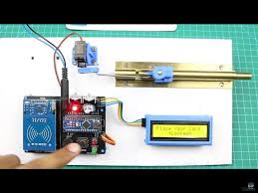

**Fig 2.4: RFID Door Lock System with Arduino**

This is a popular project for Arduino hobbyists. RFID door lock systems are very common for access control, as they provide a reliable, consistent experience with trackable data. Unlike other forms of traditional access control such as swipe cards, RFID locking systems are contactless, meaning that the credential doesn’t have to touch the reader for it to work.

Similar to a barcode reader, RFID readers work by sending and receiving data, but instead of having to scan a code, the data is transmitted over radio frequencies. An RFID door locking system requires RFID tags, antennas, an RFID reader, and a transceiver in order to function as a complete system.

In an RFID door lock access control system, the user’s credential (usually a keycard or fob with an RFID chip) contains unique identifying information called a tag. When the user comes within proximity of a reader, the reader’s signal locates the information stored on the user’s RFID tag, and sends it through antennas and transceivers to authorize the tag in the access control system. Once read, the system will either accept or deny the request to unlock the door. Data from an RFID-enabled system is automatically stored, making it possible to track entry activity in an access control system (“Nikhil”, 2019).

1. **RFID Token Based Appointment Calling System**

Token based appointment calling systems are widely used by doctors, canteens, servicing/repair and similar applications. Manual token calling systems have following issues:

There may be mistakes in calling tokens by order of arrival

There may be favoring/discrimination by the token caller

A dedicated person is always needed to keep it operational

Well we here design a fully automated token management system that solves all these issues. The system allows for fully automatic token calling system that can operate without any errors.

The system makes use of an Atmega 328 microcontroller along with an RFID reader for sensing REID token numbers, a keypad for settings, an LED Display and buzzer for notifying and displaying token number along with basic electronics components and PCB board to develop the system (“RFID Token Based Appointment Calling System”, 2022).

1. **IOT Smart Parking Using RFID With Android App**

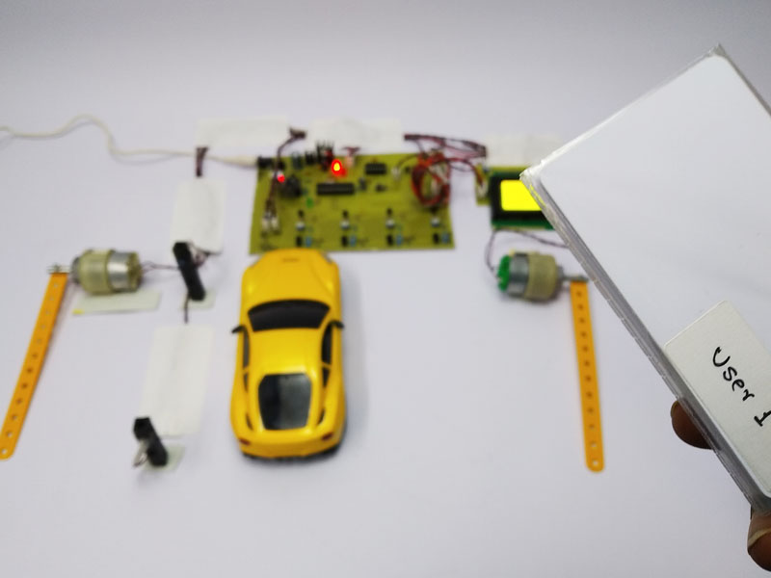

**Fig 2.5:** **IOT Smart Parking Using RFID With Android App**

There has been a tremendous growth in the number of vehicles on road in past few years. But unfortunately, the road networks and road widths have not grown in proportion to vehicle numbers. This has created in huge parking crisis especially in urban areas. At such times smart online parking systems are the need of the hour.

This system aims at replacing the conventional parking system with an IoT-based smart parking system by using RFID (radio-frequency identification). The users will be provided an entry card for getting access to the parking slot. The users will also be provided with an android based mobile application, using which they can know about the availability of the parking slot on their mobile phones. The users will need to maintain a minimum amount of balance in their entry card for getting access through the parking system, otherwise, the system will deny the access to enter. In this way, this smart parking system will help reduce human effort & time by using automation technology.

This IOT smart parking system provides the following advantages:

Automatic Parking System with Zero Human Intervention

* RFID Scan for Access Verification
* Automatic Gate Barriers for Entry Exit
* Parking Slot Sensors for Empty Slot Detection
* Online Parking Slot availability on Phone
* Easy to Use System

The system makes use of multiple technologies to achieve the smart parking capability. This includes RFID scanner, Esp8266 WIFI Module, module motors, IR sensors, Microcontroller and electronics components to develop this system. The microcontroller is used to operate the entire system in order to achieve the desired operation (“ Smart Parking Using RFID With Android App”, 2022).

1. **RFID Voting System Project**

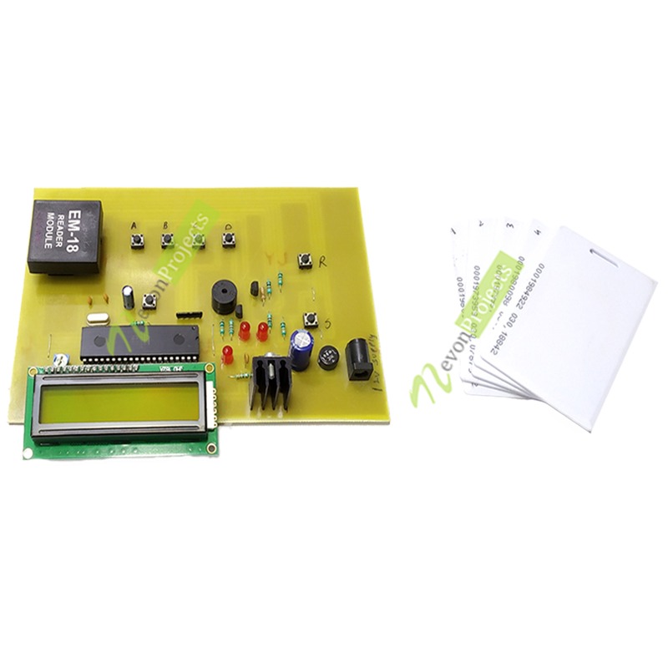

**Fig 2.6:** **RFID Voting System Project**

This project RFID based Voting project is way of authenticating voters and allowing only the authorized users to vote. The whole system includes RFID scanner to scan the voter ID cards, 8051 microcontrollers interfaced to LCD screen which will be used to display output. It also includes 4 push buttons for voting. In order to vote, the candidates will have to be registered to the system and this registration is done by scanning the voter ID card against the RFID scanner. While voting, the information on the card is then matched with the stored in the microcontroller, if the data matches microcontroller displays a confirmation message otherwise displays a denial message on an LCD screen (“Voting System Project”, 2022).

1. **Smart Shopping Trolley with Automated Billing using Arduino**

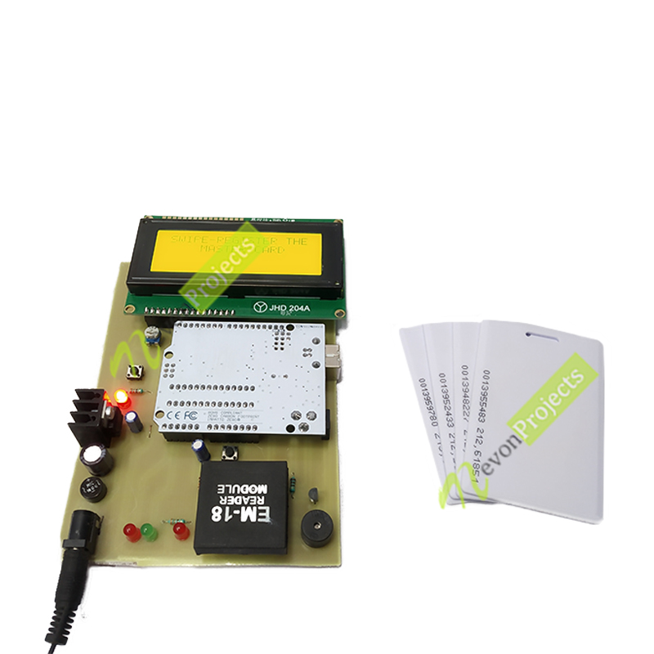

**Fig 2.7:** **Smart Shopping Trolley with Automated Billing using Arduino**

Shopping is simple but waiting on a bill counter makes shopping too boring and a tedious task. Huge amount of rush plus cashier preparing the bill with barcode scanner is too time consuming and results in long ques. This innovative project consists of an automated billing system which can be placed within the shopping trolley. This automated payment system consists of a RFID reader which is controlled by Arduino. So, whenever the shopper puts any product in trolley it is detected by the RFID module and is displayed on LCD along with the price of the product. As the shopper goes on adding products, all products are detected by the module and therefore the price will increase accordingly. In case if customer changes his/her mind and doesn’t want any product added in the trolley he/she can remove it and the price added will be deducted automatically. At the end of shopping the shopper will press the button which when pressed adds all the product along with their price and gives the total amount to be paid. At exit for verification the shopkeeper can verify the products purchased with the help of master card. Hence this technique is an appropriate method to be used in places like supermarkets, this will help in reducing manpower and helps in making a better shopping experience for customers (“Smart Shopping Trolley with Automated Billing using Arduino”, 2022).

1. **Advanced Footstep Power Generation System using RFID for Charging**

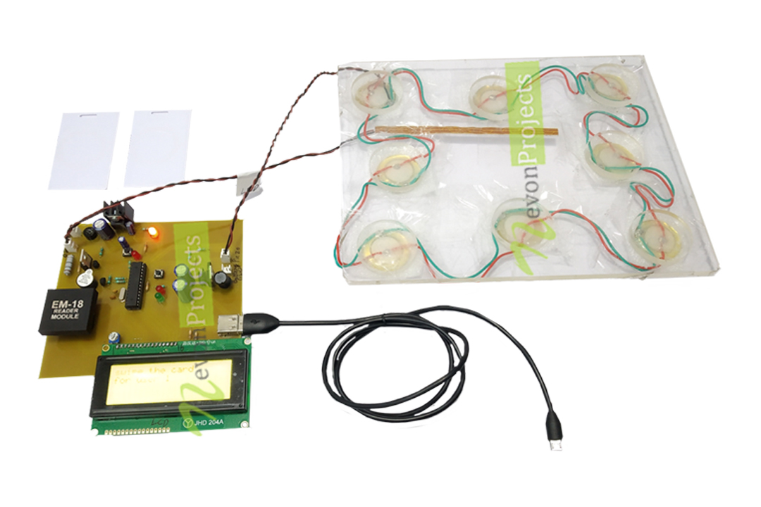

**Fig 2.8:** **Advanced Footstep Power Generation System using RFID for Charging**

Day by day, the population of the country is increasing and the requirement of the power is also increasing. At the same time the wastage of energy is also increasing in many ways. So, reforming this energy back to usable form is the major solution. In this footstep power generation project, we are generating power with the help of human’s footsteps; this power is then used to charge battery. The power is stored in a battery that can be used to charge a mobile phone using RFID card. This system is powered by Atmega 328 microcontroller, it consists of Arduino IDE, RFID sensor, USB cable and LCD. When we power on the system, the system enters into registration mode. We can register three users. Once all the user is entered in the system then the system asks to swipe the card and connect the charger. Initially all the user is given 5 minutes of charging time as default. When we swipe the card and if the user is authorized, the system turns on for charging and will charge the Mobile phone. If the user is un-authorized then the system will display as unauthorized user, just in case if the user wants to stop the charging in midway the user needs to swipe the card again. As soon as the card is swiped again, the remaining time balance is displayed and the charging stops. In order to recharge a card, we need to press recharge button which is on the system, and then system will ask to swipe the card, once the user swipes the card, it adds more 5 minutes to the particular card of the user (“Advanced Footstep Power Generation System using RFID for Charging”, 2022).

1. **RFID Based Petrol Pump Automation System**

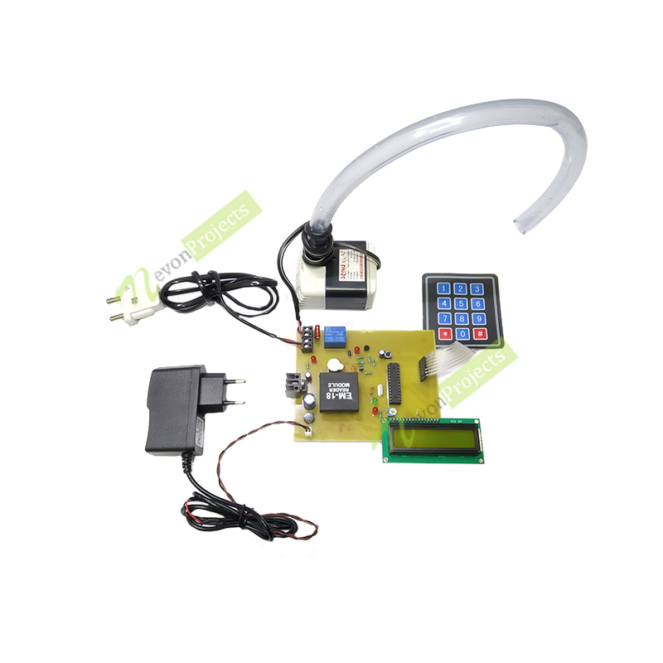

**Fig 2.9:** **RFID Based Petrol Pump Automation System**

Everything has been digitized. In many existing systems, almost all petrol pumps have a controlling unit to perform the tasks like managing the electrical pump, drive the display, measure the flow & accordingly turn OFF the electrical pump. But still a person is required to collect the money and there is a possibility of many human errors. In this proposed petrol pump automation system, we are using RFID card to access petrol at different petrol stations of different petrol companies across the country and here, we are connecting all these petrol stations using single web server. This web server access is secured by a password which is known only to the petrol companies. Whenever we want to fill the tank from the fuel dispenser, we just have to place the RFID card near the RFID reader. Then the microcontroller reads the data from the RFID reader and performs the action according to the customer requirements. This digital petrol pump system also provides the security for the customers for filling petrol at the Petrol stations by avoiding the involvement of human beings, hence reduces the risk of carrying money every time. This petrol pump system consists of Atmega328 microcontroller, RFID module, LCD display, Keypad, Ac pump and alarm. When RFID reader, reads the card it asks for the 3-digit password, if we enter wrong password more than twice it raises an alarm. And when the right password is entered is into the system, the system asks for the amount and it also shows the balance amount. On entering the amount, the motor starts and petrol gets filled in the petrol tank from the fuel dispenser (“RFID Based Petrol Pump Automation System”, 2022).

1. **RFID Based Smart Master Card for Bus Train Metro Ticketing**

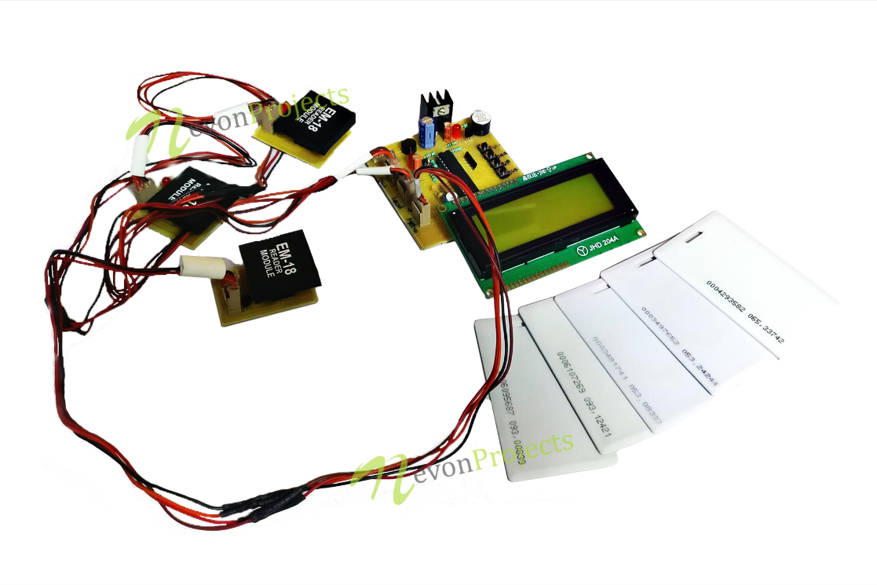

**Fig 2.10:** **RFID Based Smart Master Card for Bus Train Metro Ticketing**

Modern cities of today have developed multiple means of communication including Buses, trains, metros and private vehicles. Now each transport system has their own smart card and it becomes a hectic process for users to manage separate smart cards for every transport medium. Thus, we propose a smart master card approach that integrates all these systems together and allows for a single master card and a centralized system for all transportation mediums. To demonstrate this concept, we use three RFID scanners to demonstrate as bus train and metro train smart card scanners respectively. Now we use three smart cards that work particularly on each of the systems viz one RFID card for bus, one for train and one for metro respectively. Now we also provide one more card that is the master smart card that can work on all three scanners thus making it very easy for the user to use any transport as desired using the same card. The system also allows for source and destination selection and based on that deducts particular amount from the user master card (“RFID Based Smart Master Card for Bus Train Metro Ticketing”, 2022).

1. **RFID Mobile Charging System**

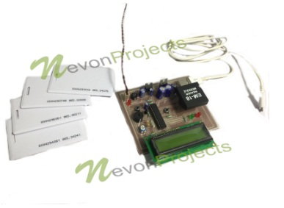

**Fig 2.11:** **RFID Mobile Charging System**

Ever been in a situation when you are having a very important conversation and your phone’s battery just dies? Ever made an important document/presentation, almost about to finish and save but the phone turns OFF and POOF goes the document? These things happen all the time. Our lives have become so hectic that, we just can’t get enough from our phone’s battery. It might happen that many a times you don’t even get a chance to charge your phone to last a day. At such a time, our project RFID mobile charging comes to the rescue. Battery about to die, no need to worry; our system can give you those few crucial minutes at just a swipe of a card.

This project features an RFID card reader, to recognize a user. Once a valid user has been identified the system then starts recharging the mobile. Before a user can charge his/her phone, he/she has to register their respective card/cards. Our system can register 3 users at one time. After registering, the user is credited 5 minutes of mobile charge. So now, the user must connect a phone to the charging port and swipe the card. Once identified as a valid user the system starts charging the phone. Along with charging, the system also keeps a record of how much charging time the user has got left, this remaining time is displayed on an LCD. If the user is running short on time and needs to unplug the phone, he/she can swipe their respective card and the charging will stop. The remaining time of the user will be saved by the system and the user can charge his/her phone later. Another important feature of this system is Extra Charge; incase a user needs more charge; this can be done quite simply. A button is provided on the system for Extra Charge, by pressing this button the user gets an additional credit of 5 minutes over the remaining charge time. Furthermore, if an Invalid user tries to recharge his/her phone by swiping the card; the system tries matching it with the valid IDs stored. But since this user isn’t registered, the system shows Invalid user and doesn’t credit any charging time.

So, in this way, we have made a system which enables the users to charge their phones for crucial moments at very affordable prices. So, say goodbye to dying batteries and say hello to RFID mobile charging (“RFID Mobile Charging System”, 2022).

1. **RFID Attendance System with SMS Notification**

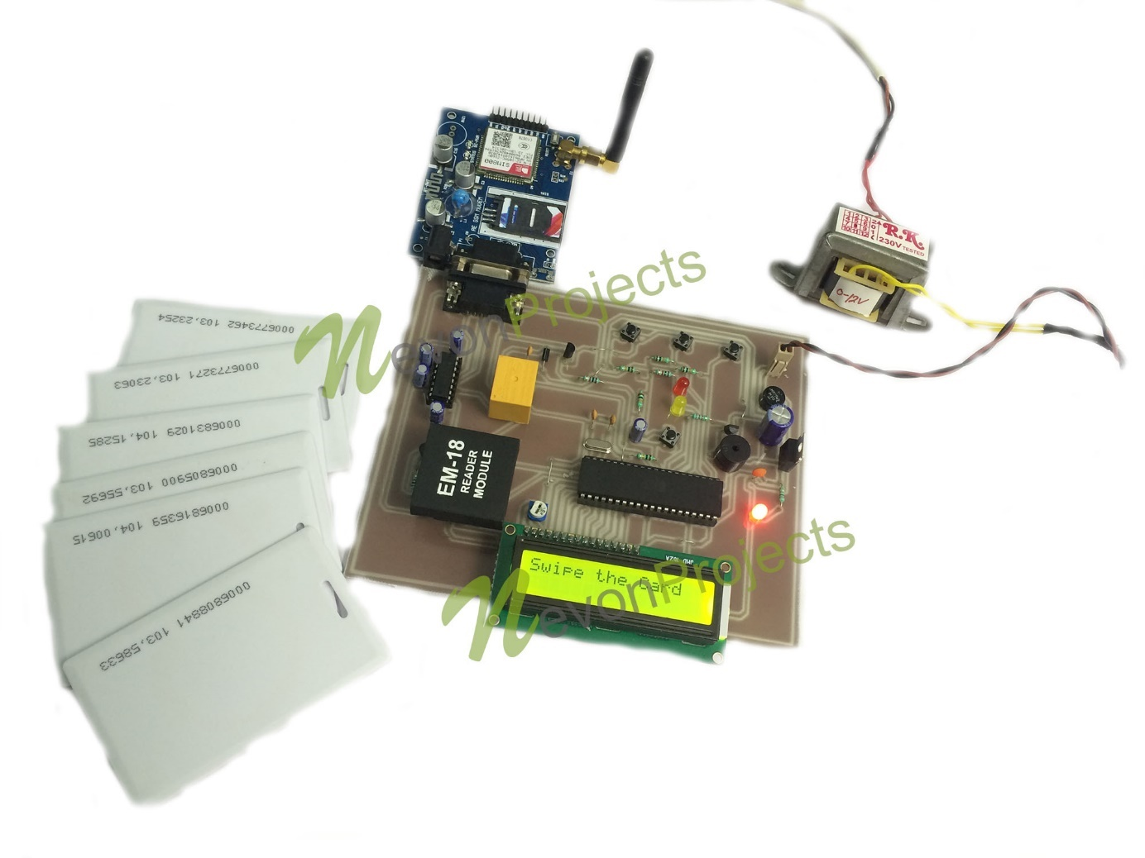

**Fig 2.12:** **RFID Attendance System with SMS Notification**

Here we have an automated RFID based attendance system with SMS notification to parents. This system automates the attendance system by checking attendance using RFID cards as well as informs parents when student enters and leaves the academic premises. In this system we use RFID tagging cards to demonstrate as user I cards. We use a microcontroller-based circuit with RFID reader, LCD display, buzzer and GSM modem. The system is powered by a 12V power supply. When user scans a card on the RFID reader, the system recognizes the student and check is it is a valid student card. If the student is valid, system marks attendance and also sends an SMS notification to the parents of the students about student. Thus, the parents are alerted when student enters or exits the premises. The RFID reader is interfaced to the microcontroller. The microcontroller constantly checks the reader for any id scanned. Whenever a card is scanned, the system provides the signal with card id to the microcontroller. The microcontroller on receiving the signal now displays the status of the event on LCD display. If the card is one of the cards already enrolled in system, it recognizes the card and checks the contact number entered for that particular card. It then sends an SMS to that particular number to inform about the card scan. The microcontroller uses the GSM modem to send the SMS message to particular number (“RFID Attendance System with SMS Notification”, 2022).

1. **Summary of the Problem of Existing Systems**
2. The machines are very rigid. The keys are stored directly on the hardware.
3. The machines are large and cannot be carried around easily.
4. There are no means to monitor how the system is being used, microcontrollers aren’t known for having much storage memory
5. The machines do not make use of the web/internet.
6. The data is not persistent, in case of a power outage all data is lost.
7. It is very difficult to update/maintain. Any required changes mean the machine has to be dismantled down to the microcontroller
8. **Summary of Related Literature**

Microcontroller/IoT technology can be used to build powerful applications. The above referenced examples show just how versatile RFID technology can be and how it makes the life of people easier. Their biggest draw-back is even though they do a lot, they do not leverage the power of the internet. The power of the internet when combined with these or any project brings about interesting results; where data can be easily stored and retrieved from anywhere at any time. This study will make use of an online web app and an RFID scanning machine. When a card/tag is presented to it, operations/communication occur between the server and the machine. Data is stored and recorded in a very secure and persistent manner. The web app and the hardware device achieve perfect harmony and productivity. Both of them covering each other’s weaknesses.

**CHAPTER THREE**

**METHODOLOGY**

1. **Design Consideration**

The proposed RFID Smart Card Reader is a software – hardware hybrid, that detects student ID cards as input, sends this input to the server and return a true or false (red or green lights), depending on what operation was done. The hardware consists of:

* Node MCU ESP8266 Microcontroller
* MRC522 RFID Sensor and its Tags
* A Buzzer
* 9V Batteries
* I/O Switch
* LED’s (Red, Green, Yellow, Blue)

The software is a web application hosted on an Apache hosting service built with:

* HTML
* CSS
* PHP
* JavaScript
* MySQL

At the end of development, the hardware should be able to read a student’s ID card, send this info to the server, and get a true or false response.

1. **Summary of Project Methodology**

After coupling all the hardware parts and making sure the Wi-Fi connects successfully, the software/web app should be built and the correct API endpoints setup. The hardware should be able to read a student’s ID card, send this info to the server, the server confirms if he or she has performed a task like paying school fees, paying departmental/faculty fees and returns a true or false reply. The hardware device displays this as either Red(false) or Green(true).

1. **Data Source/Collection**
2. Manual Registration/Entries: The web app is built to allow Staff and Students to register. This includes assignment of individuals to unique ID cards
3. Mockaroo Test Data: Mockaroo is an online service that allows users create mock data, up to 1000 rows, in many formats including: JSON, CSV, SQL and so on.
4. Usage: With every card scan, data is stored. The users name, context of use, date, time and so on.
5. **Hardware Requirements**
6. Power supply of 9 to 12 Volts is recommended for the Node MCU Microcontroller
7. The Wi-Fi hotspot name (SSID) and its password, must be set to what is specified for the device to connect successfully
8. A stable internet connection on the Wi-Fi hotspot enabled device.
9. A working RFID tag
10. Arduino IDE: This is a free and open source Integrated Development Environment(I|DE) used for programming Arduino based microcontrollers and building IoT devices.
11. **Software Requirements**
12. VS Code IDE: This is a free and open source Integrated Development Environment(I|DE) used for programming vast amounts of programming languages through its publicly available extensions.
13. Apache Web Server: This is a free and open source web server that powers a very high percentage of the web. It contains support for multiple programming languages (PHP, Rust) and multiple Database Management Systems (SQL, Postgress)
14. Postman: This is a free and open source tool used for simulating, testing and troubleshooting web API’s
15. Google Chrome: This is a popular web browser created by Google. Used for surfing the web and using our web app.
16. **Block Diagram of Proposed System**

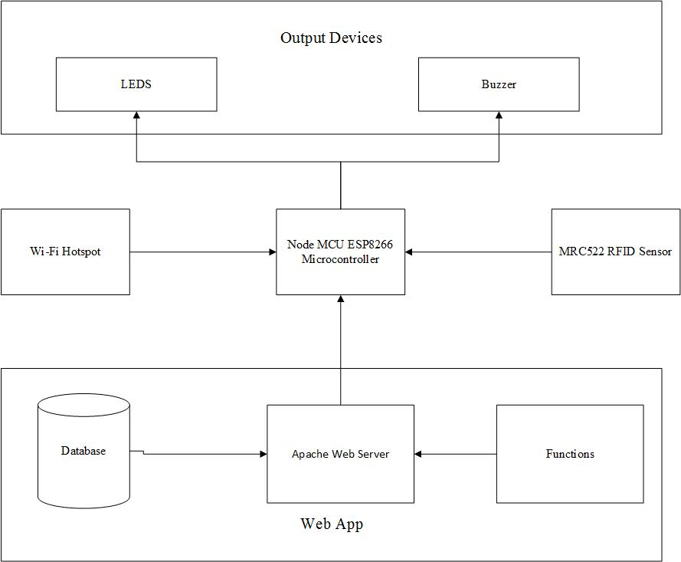

**Fig 3.1: Block Diagram of Both Hardware and Software Systems**

A Block diagram is a diagram of a system in which the principal parts are represented by blocks connected by lines that show the relationship of the blocks. The above diagram shows the relationship between the NodeMCU microcontroller and the other components

1. **Software Unified Modelling Language Diagrams**

Unified modelling language (UML) is a powerful language that can be used to represent all concepts that exist in Object Oriented analysis and designs. It is a way of visualizing and documenting a software system by using a collection of diagrams, thus making it easy to understand.

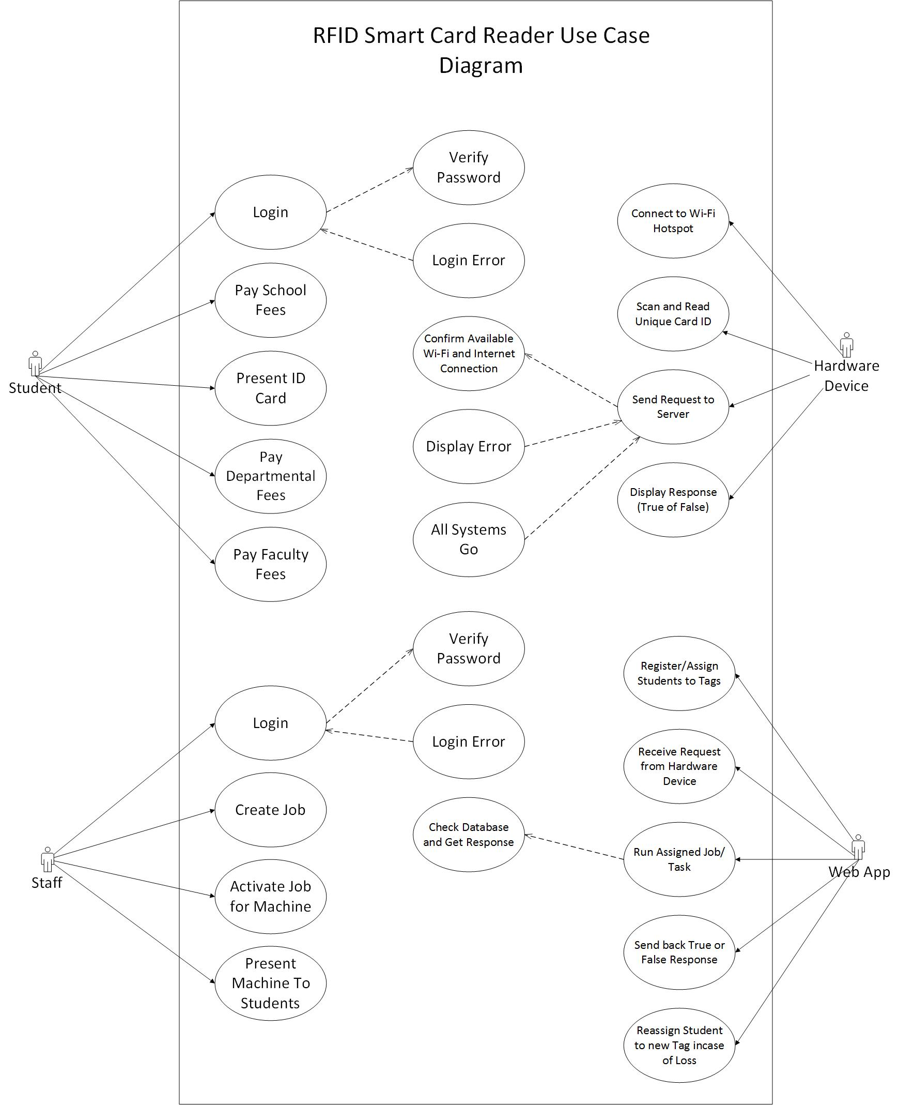

**Fig 3.2: UML Use Case Diagram of Smart RFID Card Reader**

Above is a high-level diagram that shows the system, people and basic workflow of your application/ideas.

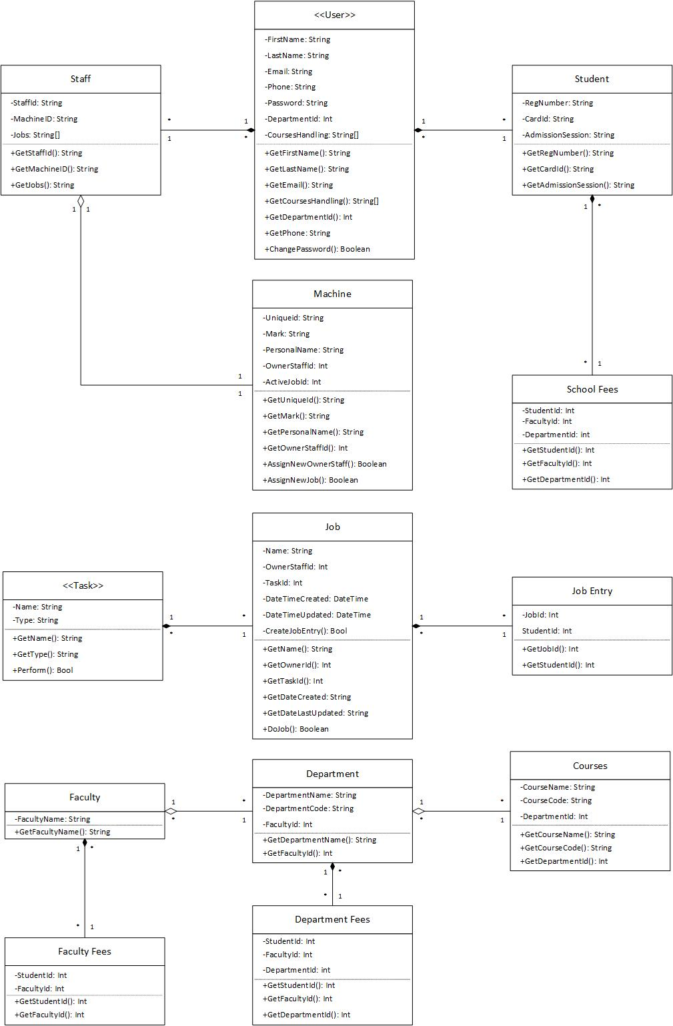

**Fig 3.3: UML Class Diagram of Smart RFID Card**

This is a high-level diagram made up of Classes, their relationships with one another, and their attributes.

**CHAPTER FOUR**

**RESULTS AND DISCUSSION**

1. **Implementation Procedures**

At the end of development, we have a very light weight device connected to a hosted web app through the internet with Wi-Fi. After the hardware was wired, soldered, coupled and programmed using Arduino IDE, it went through a rigorous testing phase for speed and durability. Next, was the software/web app. The UML Use case and Class diagrams helped to guide the next phases of development. The SQL database was built first with several tables including:

* Students
* Staff
* Machines
* Tasks
* School Fees
* Departmental Fees
* Faculty Fees
* Jobs
* Job Entries
* Faculties
* Departments
* Courses

The coding went next, with the appropriate user interface built with HTML, CSS, JavaScript, then the server-side code written with PHP. The web app has a page that accepts GET requests comprising of the Machine ID and the Unique card ID of a student. Once received, the web app confirms the task assigned to it by the lecturer then proceeds to check the database for what is required. This results a true or false value depending on how successful the task went. The code for both the hardware and software are hosted online at: <https://github.com/Emerald2240/School-Students-ID-Card-Activity-Hub--S.S.I.A.H/>

1. **Wiring / Assembly**

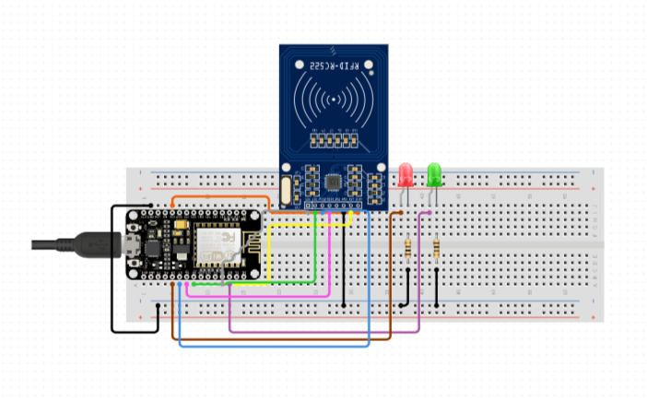

**Fig 4.1: Breadboard Wiring of The System**

In Figure above, the base/prototype wiring of the project is shown on a bread board. The NodeMCU is powered by a type-a USB cord. The wiring configurations:

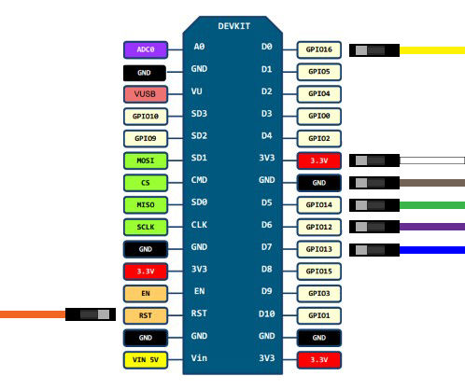

**Fig 4.2:** **NodeMCU Pin/Wiring Configurations**

The NodeMCU ESP8266 12-E chip comes with 17 GPIO (General Purpose Input Output) pins. Not all GPIOs are exposed in all ESP8266 development boards, some GPIOs are not recommended to use, and others have very specific functions.

**Table 4.1: RFID Sensor and its Pin Connections to the Node MCU**

|  |  |
| --- | --- |
| **MRC522 RFID Sensor Pins** | **Node MCU Pin** |
| SDA | D4 (GPIO2) |
| SCK | D5 (GPIO14) |
| MOSI | D7 (GPIO13) |
| MISO | D6 (GPIO12) |
| IRQ | Not Connected |
| GND | GND |
| RST | D3 (GPIO0) |
| 3.3V | 3V3/3.3V |

**Table 4.2: Other Components and their Pin Connections to the Node MCU**

|  |  |
| --- | --- |
| **Other Components** | **Node MCU Pins** |
| Red LED | D0 (GPIO16) |
| Green LED | D1 (GPIO5) |

The tables above show the connections between the microcontroller, LEDs and RFID sensor. Some more LEDs and a Buzzer was added as the work progressed. When a registered RFID tag is shown to the device, it scans its unique ID and sends a request to the database. It takes less than a second for the server to respond with a true or false value. If the server returns a false, the red LED comes on for two seconds. If the reply was true, the green LED comes on for two seconds.

1. **Coding**

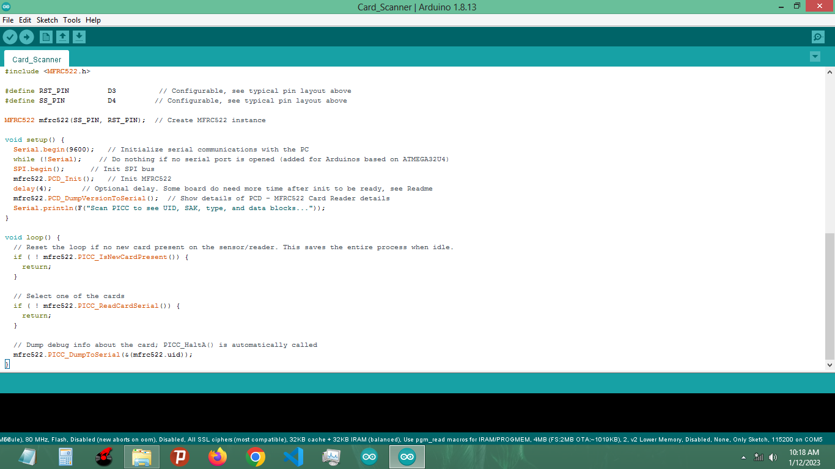

**Fig 4.3: Arduino IDE**

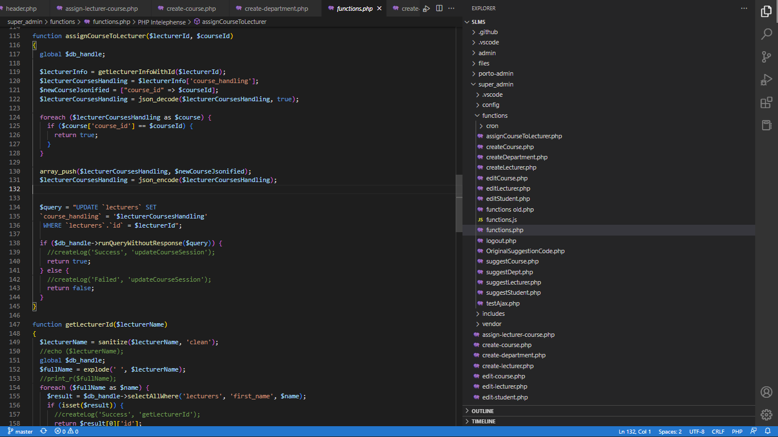

**Fig 4.4: Microsoft VS Code IDE**

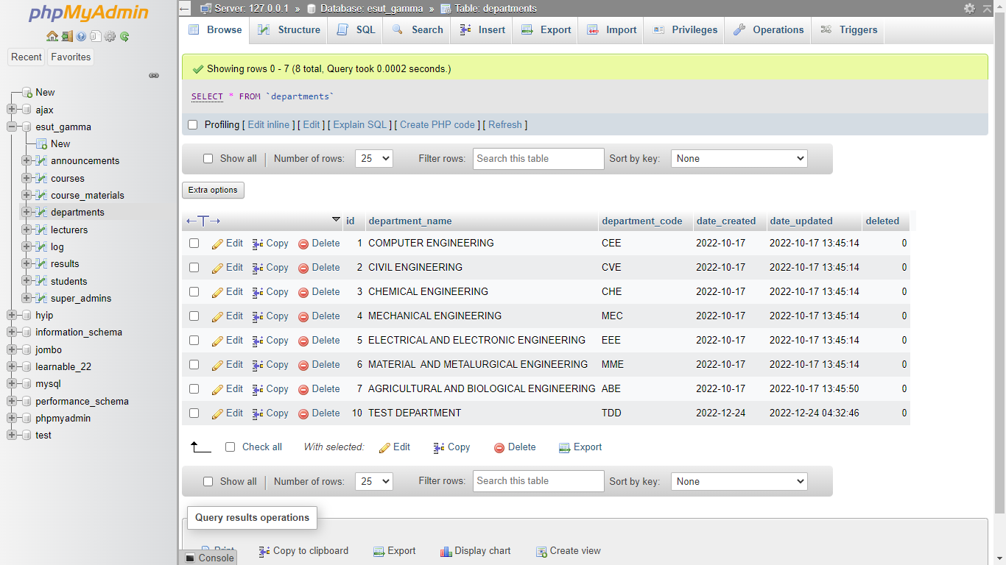

**Fig 4.5: XAMPP PHPMyAdmin Screenshot**

The above figures show the two IDE’s used to build the hybrid. The first is the official Arduino IDE used to write and upload C code to the NodeMCU. The second is Microsoft’s Visual Studio Code, an open source IDE that supports multiple languages including HTML, CSS, JavaScript, MySQL and PHP. The third image is a screenshot of the localhost XAMPP PHPMyAdmin Database management system specifically installed so code can be run on my computer.

The code for both is hosted on GitHub at: <https://github.com/Emerald2240/School-Students-ID-Card-Activity-Hub--S.S.I.A.H/>

1. **Implementation Results**

After the assembling, wiring, soldering, coding, debugging and testing; here are the results.

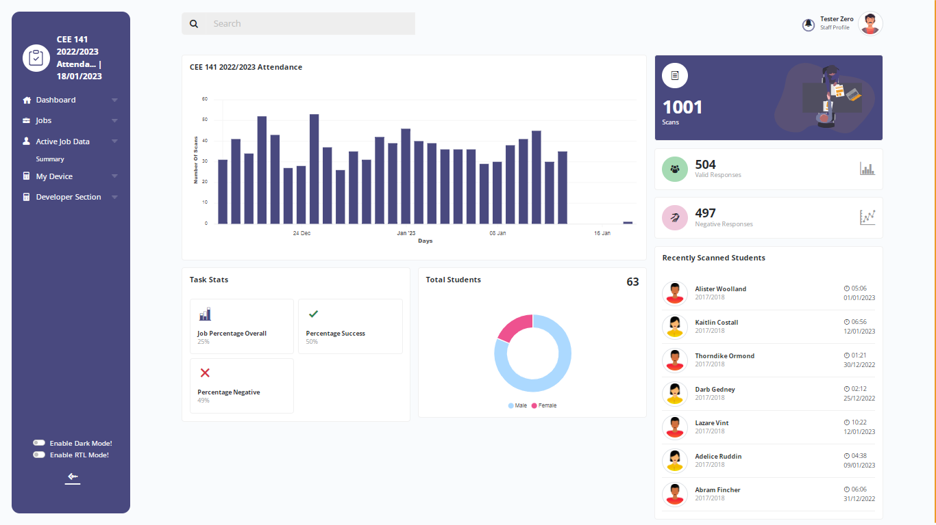

**Fig 4.6: Screenshot of Web App Staff Side Dashboard**

The figure above shows a simple screenshot of the web app UI. This particular screenshot contains very basic stats for the “Attendance Task” Job created by the currently logged in staff. Stats like Students Info, Attendance, Late coming, Absentee, Total Scans, Responses and so on. The staff is also able to download this data in two formats: CSV and Excel.

1. **Summary of Results**

The aim of this project was to build a smart card reading device that connects to the internet and stores its data online. As at the final day of development, I can say this application has reached its main purpose as stated in Chapter One.

After building and running the device for the first time, here are the results that were observed:

1. The machine is extremely Lean and can work for hours without any signs of slowing down or heat.
2. Because of its low data output, the machine is extremely fast. Returning card results within 200 milliseconds.
3. The machine is really portable and can easily fit into a pocket.
4. My beta testers found the Web app UI really clean and easy to use.
5. Data online can be easily sorted and retrieved through the web app.
6. Users loved the idea of downloading the data as excel or csv but preferred excel because of its popularity.
7. The device has shown to be secure. External readers cannot make use of the tag unique ID’s except in the extreme case of forceful collection/Stealing
8. The web app/web server showed no stress whatsoever after repeated use

**CHAPTER FIVE**

**CONCLUSION AND RECOMMENDATIONS**

1. **Conclusion**

This paper presents a comprehensive survey of a fully functional IoT device that works to gather what used to be manually retrieved information, and digitize it. This device will make the lives of students and staff alike easier, by: reducing manual tasks and carrying around of hardcopy evidence for students; It will save the space used by librarians and admin officers for storing documents; It will reduce the carbon footprint created through the burning of unneeded documents; It will also boost data analysis by offering huge insights into the behavior and activities of students in and around the school.

**5.2 Problems Encountered/Limitations**

Below are the list of issues or problems I encountered while building the device.

1. Updating server code was data expensive, I had to make two uploads, one to GitHub and one to my cloud hosting. I discovered GitHub actions and it made my life easier. I only need to upload code to GitHub once and it does the rest for me.
2. Understanding the NodeMCU pin counterparts for Arduino, because all code samples were made for Arduino boards.
3. Unable to mount an LCD screen because all the Node MCU pins were in use. Opted for LED’s instead.
4. Sometimes bad internet connection

**5.3 Recommendations/Suggestions for Future Work**

I strongly recommend that more research should be carried out in this very project, as further development will strongly improve the lives of people and also benefit companies, industries and small-scale business too.

**References**

Gillis, A. (2022). What is the Internet of Things (IoT). *Tech Target*. <https://www.techtarget.com/iotagenda/definition/Internet-of-Things-IoT>

Apache HTTP Server. (2022, April 22). *In Wikipedia*. <https://en.wikipedia.org/wiki/Apache_HTTP_Server>

Arduino. (2022, April 22). *In Wikipedia*. <https://en.wikipedia.org/wiki/Arduino>

General Purpose Input/Output. (2022, April 22). *In Wikipedia*. <https://en.wikipedia.org/wiki/General-purpose_input/output>

JavaScript. (2022, April 22). *In Wikipedia*. <https://en.wikipedia.org/wiki/JavaScript>

Nikhil, A. (2019). Arduino Based RFID Door Lock. *Engineers Garage*. <https://www.engineersgarage.com/arduino-rfid-rc522-door-lock/>

Moreno, R. (2019, March). *Elegoo Arduino Lessons*: *Lesson 21 – RC522 RFID Module.* [Video]. <https://www.youtube.com/watch?v=gTQmLkwnUxk&ab_channel=RicardoMorenohttps://www.youtube.com/watch?v=gTQmLkwnUxk&ab_channel=RicardoMoreno>

NodeMCU. (2022, April 22). *In Wikipedia*. <https://en.wikipedia.org/wiki/NodeMCU>

Microcontroller. (2022, April 22). *In Wikipedia*. <https://en.wikipedia.org/wiki/Microcontroller>

PHP. (2022, April 22). *In Wikipedia*. <https://en.wikipedia.org/wiki/PHP>

MySQL. (2022, April 22). *In Wikipedia*. <https://en.wikipedia.org/wiki/MySQL>

Radio Frequency Identification. (2022, April 22). *In Wikipedia*. <https://en.wikipedia.org/wiki/Radio-frequency_identification>

Wi-Fi. (2022, April 22). *In Wikipedia*. <https://en.wikipedia.org/wiki/Wi-Fi>

Visual Studio Code. (2022, April 22). *In Wikipedia*. <https://en.wikipedia.org/wiki/Visual_Studio_Code>

Ene, P. (2022, June 10). Problems of Science and Technology Development in Nigeria. *WALYBEN.* [https://www.walyben.com/problems-of-science-and-technology-development-in-nigeria/#:~:text=Lack%20of%20Funds%3A%20Science%20and,technological%20growth%20in%20the%20country.](https://www.walyben.com/problems-of-science-and-technology-development-in-nigeria/%23:~:text=Lack%20of%20Funds%3A%20Science%20and,technological%20growth%20in%20the%20country.)

RFID Token Based Appointment Calling System. (2022). *Nevon Projects*. <https://nevonprojects.com/rfid-token-appointment-calling-system/>

IOT Smart Parking Using RFID With Android App. (2022). *Nevon Projects*. <https://nevonprojects.com/iot-smart-parking-using-rfid-with-android-app/>

RFID Voting System Project. (2022). *Nevon Projects*. <https://nevonprojects.com/rfid-voting-system-project/>

Smart Shopping Trolley with Automated Billing using Arduino. (2022). *Nevon Projects*. <https://nevonprojects.com/smart-shopping-trolley-with-automated-billing-using-arduino/>

Advanced Footstep Power Generation System using RFID for Charging. (2022). *Nevon Projects*. <https://nevonprojects.com/advanced-footstep-power-generation-system-using-rfid-for-charging/>

RFID Based Petrol Pump Automation System. (2022). *Nevon Projects*. <https://nevonprojects.com/rfid-based-petrol-pump-automation-system/>

RFID Based Smart Master Card for Bus Train Metro Ticketing. (2022). *Nevon Projects*. <https://nevonprojects.com/rfid-based-smart-master-card-for-bus-train-metro-ticketing/>

RFID Mobile Charging System. (2022). *Nevon Projects*. <https://nevonprojects.com/rfid-mobile-charging-system/>

RFID Attendance System with SMS Notification. (2022). *Nevon Projects*. <https://nevonprojects.com/rfid-attendance-system-with-sms-notification/>